ANALYSIS OF MULTI-SOURCE CIRCUITS

Tellegen’s Theorem: conductance multi-port with one output.
For all branches
v^{T}. j’ = v’ ^{T}. j = 0.
Splitting port branches and internal branches, and assuming only resistors and transconductances in the multi-port circuit N, Tellegen’s theorem gives
[v^{T}. j’]_{port} + [v^{T}. G’.v’]_{int} = [v’^{T}. j]_{port} + [v’^{T}. G.v]_{int}
If N’ is the adjoint of N, then G’ = G^{T}. Since [v’^{T}. G.v]_{int} is a scalar, it is equal to its transpose, and hence
[v’^{T}. G.v]_{int} = [v’^{T}. G.v]_{int}^{T} = [v^{T}. G’.v’]_{int} .
Therefore, also
[v^{T}. j’]_{port} = [v’^{T}.j ]_{port}
To analyze the multi-source circuit N, in N’ choose the source at the output port as 1 A (if we want an output voltage v_{o} ) or -1 V (for i_{o}), and all sources equal to zero.
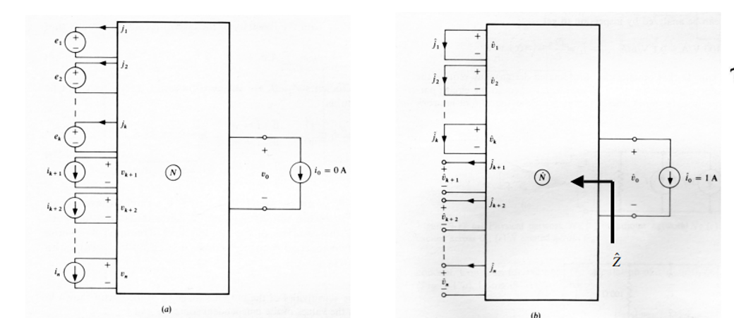
Then v_{o} = V.I_{v}’ + J.V_{j}’, where V and J are the sources in N, and I_{v}’ and V_{j}’ are in the same branches of N’. This also gives all gains from the sources to the output.
In addition, the output impedance of the physical network for V = 0 and J = 0 is given by
Z = -v_{o}/i_{o} = -v_{o}’/i_{o}’ = v_{o}’.
Thus, the complete Thevenin equivalent of the physical circuit N can be found from a single analysis of N’.

